Historical Shifts and Geographical Drifts: An Exploration of AI Embedding Space

Who are we?
This project brought together an interdisciplinary team spanning computer science, engineering, media and visual arts, statistics, linguistics, design, and the social sciences.

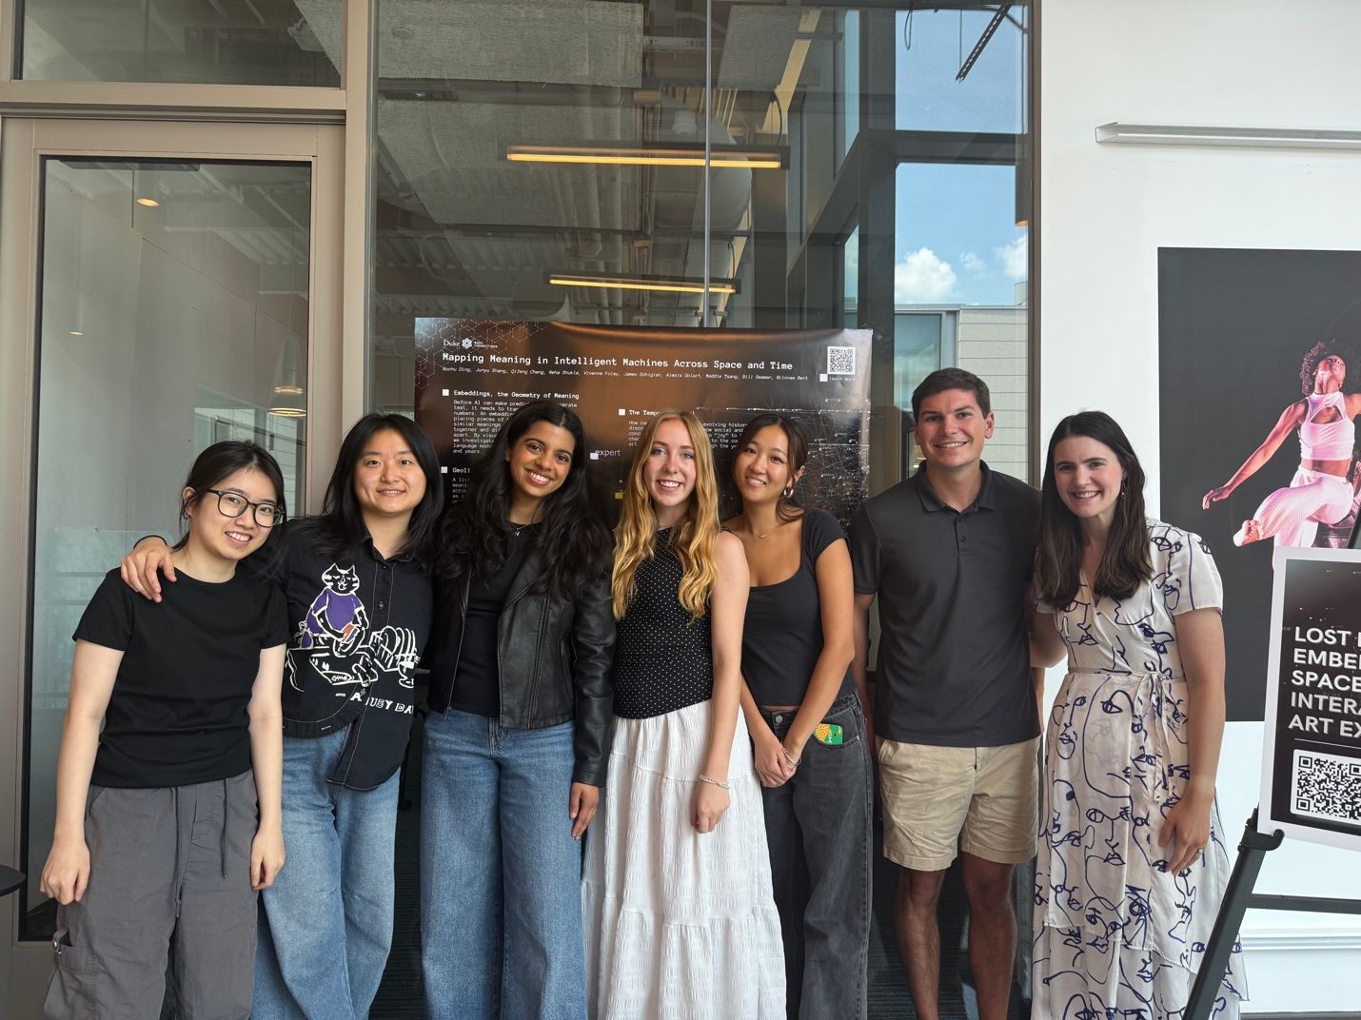
Team Members at final art exhibit. From left: Junyu Zhang, Qifeng Cheng, Neha Shukla, Alexis Golart, Maddie Tsang, James Sohigian, Dr. Brinnae Bent. Not pictured: Bochu Ding, Vivienne Foley, and Dr. Bill Seaman.

Why were we doing this?
Before AI can make predictions or generate text, it needs to translate words into numbers. An embedding model does this by placing text into a “map” where words with similar meanings are located closer together and those with different meanings are located farther apart. We set out to investigate how meaning changes within these embedding models across time and language. Not only did we want to research these changes, but we wanted to create new ways of visualizing these changes for a general audience.

The temporal team focused on how AI-related and value-laden words evolve over time, examining how their meanings have shifted over the past 30 years across different contexts. In parallel, the geolingual team asked whether AI systems represent the same concepts consistently across languages, or whether meanings drift depending on linguistic and cultural context. The arts team brought these efforts together with a complementary goal: to take the research of the other two teams and make it accessible to the public through an interactive art exhibit open to all. The aim was to turn complex research into something people could actually engage with and understand – something they could walk through, explore, and experience.

What were we trying to do?
The goal of this project was to make meaning in AI systems both measurable and understandable. Embedding space is central to how AI represents language, yet it is a black box. We aimed to study how meaning shifts across time and language, while also making those shifts visible and intuitive.

The arts team focused on making embedding space accessible to a broad audience, transforming an abstract concept into something interactive and interpretable. The temporal team built a visualization pipeline to track how AI-related and value-related words change over time across different contexts and explored whether adding temporal encoding to transformer architectures improves performance on time-related tasks. The geolingual team measured cross-lingual semantic drift, comparing how concepts move across languages and testing whether socially and politically loaded terms shift more than concrete ones, as well as how these patterns vary across models.

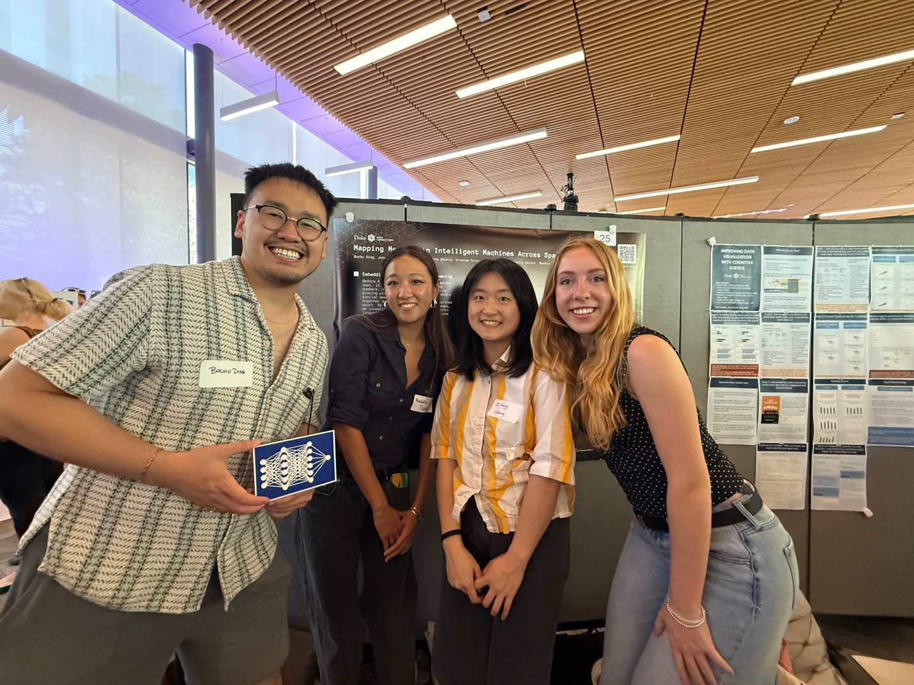
Presenting our poster at the Bass Connections Showcase. From left: Bochu Ding, Maddie Tsang, Qifeng Cheng, Alexis Golart.

What did we do?
The arts team created a two-part interactive exhibit at the Rubenstein Arts Center, “Lost in Embedding Space”. One installation visualized the temporal team’s work as a walkable timeline of embedding space from 1995 to 2024, allowing users to see how AI-related language has evolved. The second installation translated the geolingual analysis into tree structures, where each concept appeared as a set of branches representing different languages, with nearest neighbors showing how meanings diverge or align across cultures. The installations combined sensors, 3D printing, and visual projections to create an immersive, interactive experience. You can learn more about the exhibit here: https://www.duketrustlab.com/lost_in_embedding_space

The temporal team developed a visualization pipeline by fine-tuning embedding models on 30 years of data from both academic (arXiv) and public (newspaper) sources. They generated word embeddings for a fixed set of technical and value-related terms and used UMAP to reduce high-dimensional embeddings into a 2D space for visualization. In parallel, they trained three transformer models—a baseline and two variants with temporal encoding—to test how explicitly modeling time affects representation and performance.

The geolingual team built a multi-stage pipeline to measure cross-lingual semantic drift. They constructed a concept inventory, collected parallel sentences across six languages, and embedded them using multiple multilingual models. Using cosine similarity, they compared how concepts shift across languages and models, producing both quantitative analyses and visualization-ready outputs. These results directly informed the exhibit, especially the tree visualizations that made differences in meaning across languages understandable.

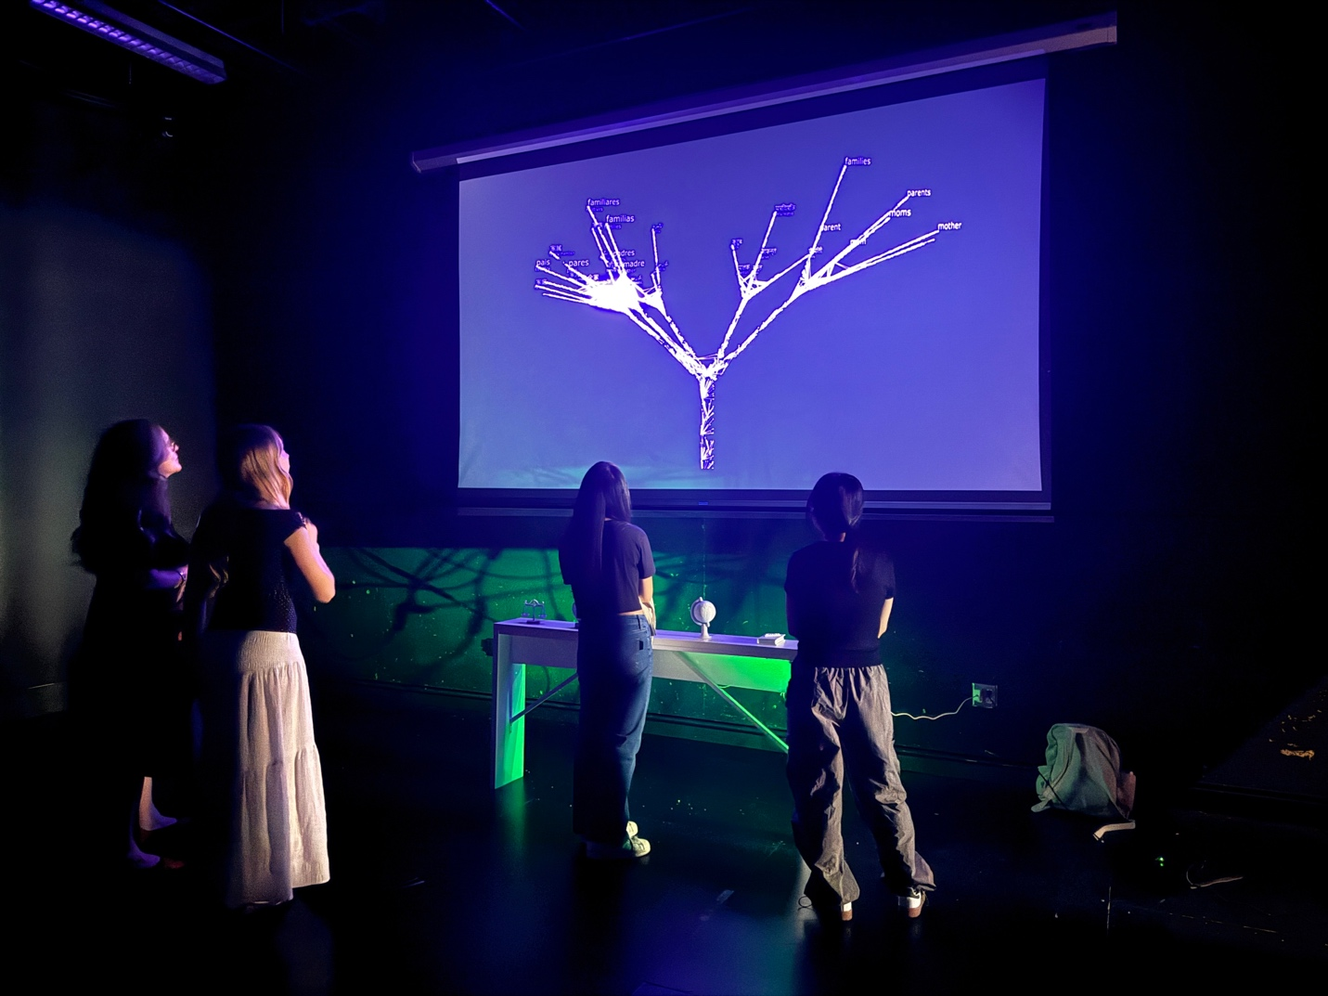
Members of the public enjoying the Geolingual Growth Art Installation; exhibited at the Rubenstein Art Center on April 25.

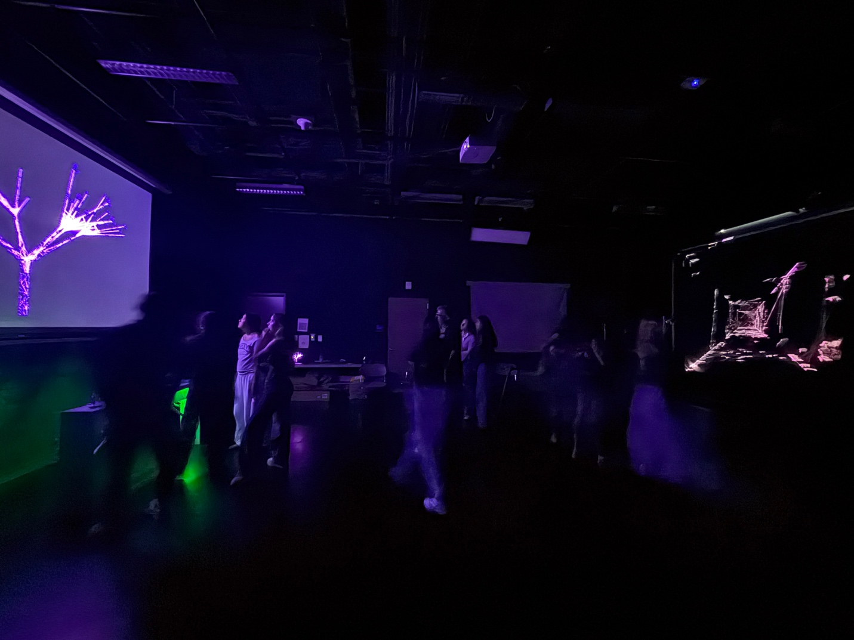
“Lost in Embedding Space” consisted of two installations on exhibit at the Rubenstein Arts Center.

What did we learn from this experience?

Maddie Tsang (‘28, Computer Science and Visual Media Studies)
Bass Connections was an amazing opportunity to explore interdisciplinary research and learning in such a close knit setting. Our project was so special in how we took data and transformed it with creativity, turning embedding into emotions. I am so grateful for all of my team members and professors who were endlessly supportive and inspiring. It was amazing to see how everyone’s unique expertise came together to create our final installation. I had so much collaborating and creating with this team and given the opportunity I would love to do it again!

Alexis Golart (‘28, Statistics Major & Political Science Minor)
Being a part of Bass Connections was an incredible opportunity to engage in research and gain exposure to an area I likely wouldn’t have explored so deeply otherwise. Working on the arts team allowed me to develop a stronger understanding of transformer models and embedding spaces, while approaching the material through a creative lens that I was originally passionate about. I especially appreciated the collaborative nature of the team and how it brought together undergraduates, master’s students, and PhD candidates who had such a wide range of experiences. Even the non-arts teams played a huge role in supporting our work leading up to the exhibit, which made the experience really special. Bass felt like one of the closest reflections of real-world experience and collaboration that I’ve had during my time at Duke University.

Neha Shukla (‘27, Computer Science (AI and Machine Learning concentration), Sociology Minor)

I’ve absolutely loved being a part of this Bass Connections team! This has been such an interdisciplinary learning experience with the most close-knit team, and I’m incredibly grateful for the mentorship and guidance from Dr. Bent and Dr. Seaman every step of the way. My research focused on probing linguistic bias in AI systems, creating experiments working in embedding spaces with multilingual transformer architecture and dimensionality reduction techniques. I’ve grown so much as a quantitative researcher and was so excited to connect our technical findings to broader questions about algorithmic fairness and the societal impacts of systemic bias. It was so much fun bringing the ideas we sketched and prototyped to life, and I loved translating the research I was conducting to building 3D models, Raspberry Pi circuits and sensors, interpretable visuals, and an interactive art exhibit. This journey has taught me to find resilience as a researcher and deepened my love for sticking with a problem and chipping away at finding solutions. Seeing our interactive exhibit come together and the public engaging with our findings felt like the most special culmination of all of our progress over the year. I’m so grateful to our incredible professors for giving us true freedom to explore and create, and to the best team for bringing our vision to life!

James Sohigian (‘28, Mathematics & Computer Science, Chinese Minor)
This Bass Connections project bridged my theoretical understanding of word embeddings that I learned in the classroom with interpretable and practical applications on real-world data. Over the course of the year, I have gained insight into model fine-tuning, embedding spaces, dataset cleaning, dimension reduction techniques, transformer architectures, and even AWS. The technical lessons I learned, combined with the creative and artistic thinking that my teammates exposed me to, will be with me forever. I truly appreciate the uniqueness of the project, the amazing professors who guided us, and my amazing teammates!

Qifeng Cheng (PhD ‘29, Physics, Astrophysics)
This Bass Connections project became, for me, a way of rethinking what it means to understand science- and what it means to share that understanding with others. Working with AI embeddings and data, we began with technical questions, but quickly found ourselves asking something deeper – how can this knowledge be felt, not just explained? Being part of this group made this question real. It makes me notice how much of science is often left untranslated when we speak outside our own field. And it was through this amazing team work spanning from modeling, training, data work, coordinations, and visual and physical design that made these gaps visible and bridgeable. And the way we support and step in for one another is what makes me feel both stronger and grateful. I deeply appreciate this opportunity to be part of this work. It has motivated me to continue asking and answering questions at the interaction of science and art, and about how knowledge can be shared in ways that are both meaningful and human.

Bochu Ding (MEng ‘26, Design & Technology Innovation)
What an inspiring experience. For me, Bass Connections was less about “what” and more about “who.” I was always in awe of what my teammates brought from their corners of expertise: from Maddie’s prowess with TouchDesigner & Alexis’ concepts and sketches to James’ knowledge of abstract math concepts to Qifeng’s knack for physical prototyping. There’s no other team I would have trusted to blend technical concepts, cultural sensitivity, and creative construction in such a formidable way. And of course, I can’t thank our instructors enough, especially Dr. Bent who encouraged blue-sky exploration and who spent many hours untangling ideas with me.

Junyu Zhang (MEng ‘26, Financial Technology)
Being part of this Bass Connections team was one of the most meaningful experiences I have had at Duke. As an international student and an introvert, I really appreciated how welcoming and inclusive the whole team was. My teammates, Professor Brinnae Bent, and Professor Bill Seaman created an environment where I felt comfortable contributing ideas and learning from people with very different backgrounds. As a multilingual person, I was especially excited by the way this project connected technical AI methods, such as embeddings and large language models, with broader questions about language, culture, and fairness. The project helped me see that AI is not only a technical system, but also something deeply connected to society, identity, and communication across cultures. This experience gave me a clearer direction for my future PhD research interests, especially regarding how AI can become fairer and how AI research can connect with social science, business, and real-world human behavior.

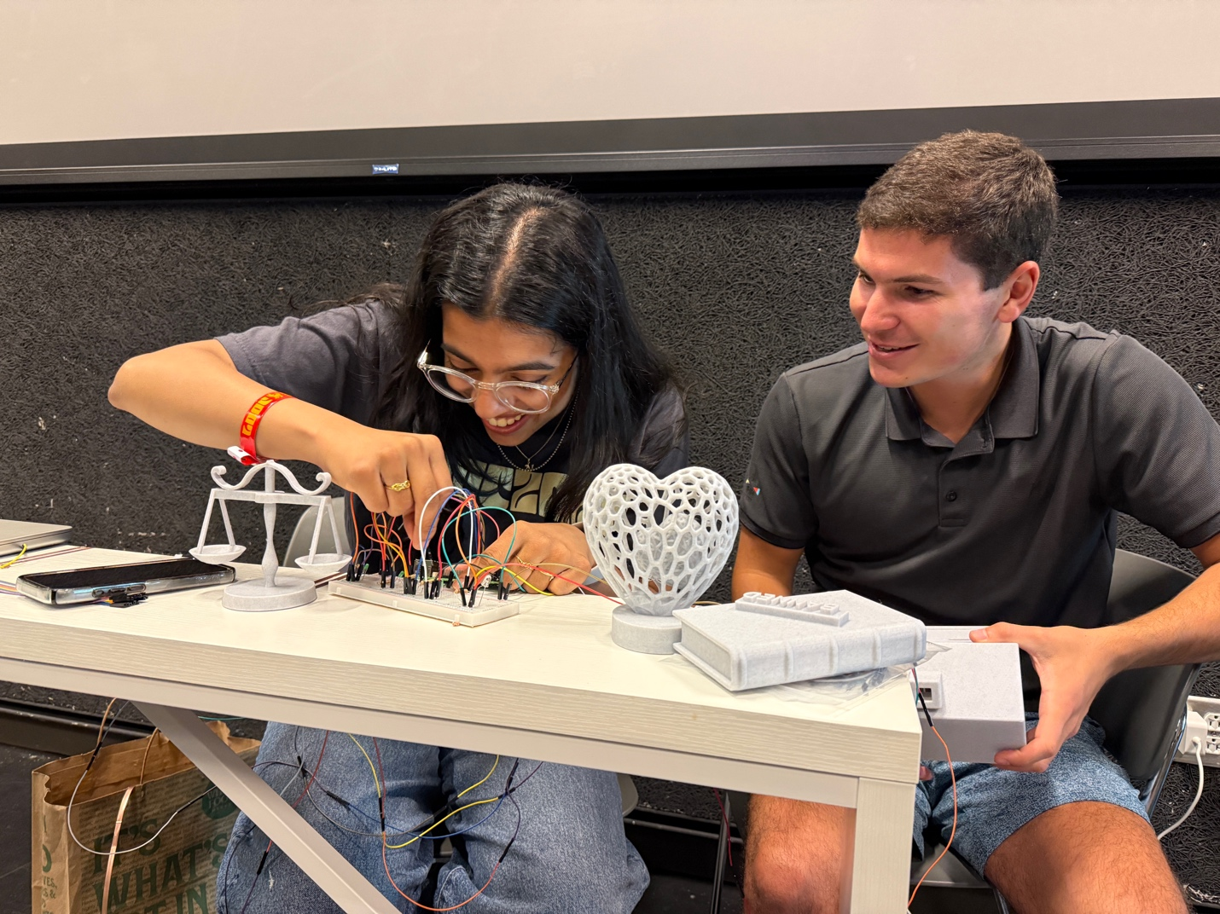
Neha Shukla and James Sohigian setting up the circuits that powered the Geolingual Growth installation.

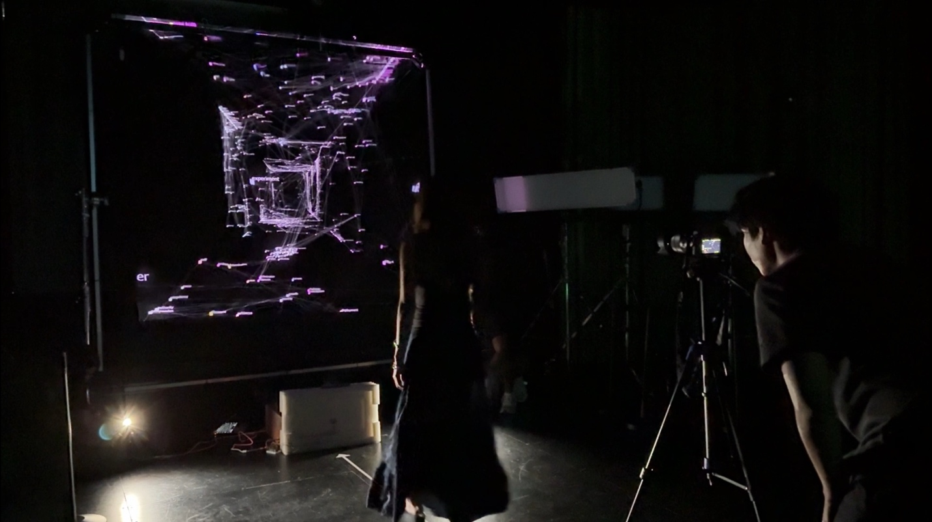
Maddie Tsang tests the Temporal Tunnel installation.
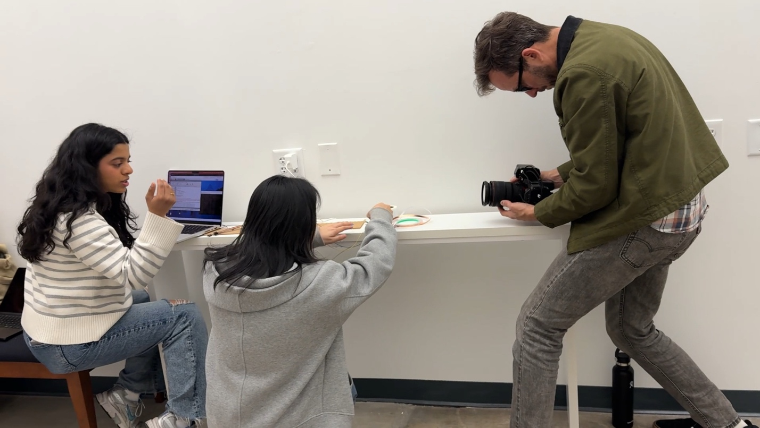
Behind the scenes filming for a Duke Campaign video. The exhibit setup was filmed for a Duke Campaign video being screened in NYC and London.

