Deep Multi-Modal Detection of Early Alzheimer’s Disease
Anika Suman, Soham Jinsi, Kelly Shahu, Xukun Zhu

Background
Alzheimer’s disease (AD) is a heterogeneous neurodegenerative disorder characterized by diverse molecular and clinical presentations. While canonical biomarkers such as amyloid-β (Aβ) and tau provide key diagnostic insight, they do not fully capture the biological variability underlying disease progression.

Recent advances in high-dimensional proteomics enable the study of thousands of proteins simultaneously, offering a more comprehensive view of disease-related molecular processes.
Electroencephalography (EEG) is a non-invasive and cost-effective method for measuring brain activity, with potential for early detection of Alzheimer’s disease. Changes in neural oscillations and functional connectivity motivate the use of EEG-derived features for classifying neurological conditions.

In resting-state fMRI analysis, brain networks are represented as weighted graphs derived from functional connectivity. To analyze these structures, persistent homology has emerged as a powerful framework, capturing multi-scale brain network organization through persistence diagrams and Wasserstein distance metrics. Furthermore, modeling these features within a Markov progression framework allows for the characterization of stochastic transitions between disease states, providing a clear probabilistic timeline for clinical decline.

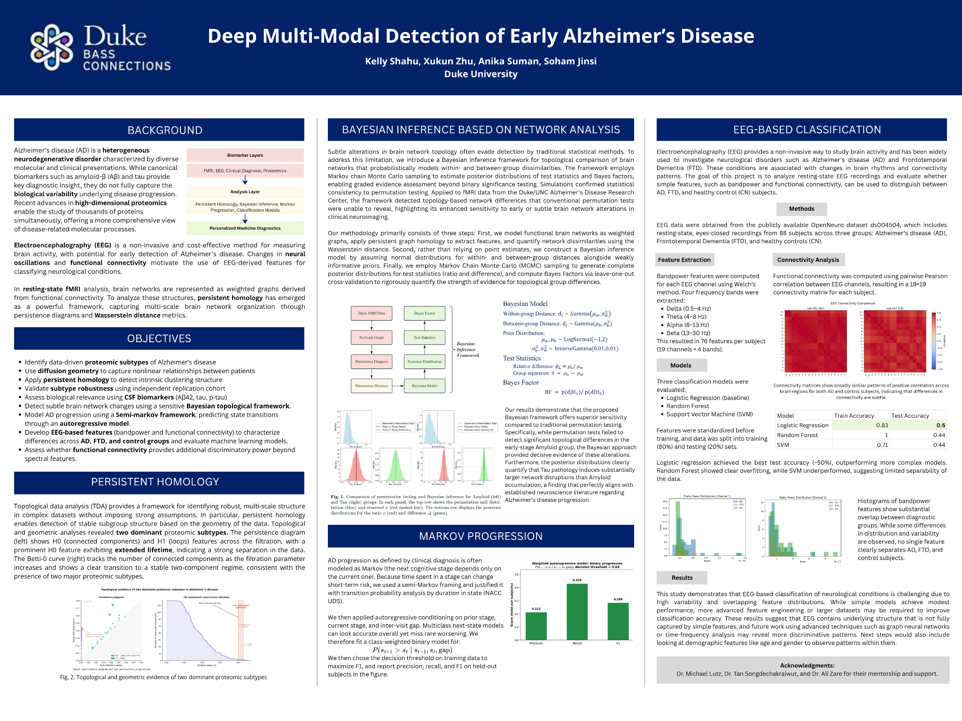
Quantifying Brain Network Changes with Bayesian Inference
Our research showed that using a Bayesian inference framework addresses some of the limitations of traditional statistical methods in detecting subtle brain network changes. This approach models functional brain networks as weighted graphs, using persistent graph homology to extract features and Markov Chain Monte Carlo sampling to generate complete posterior distributions. By computing Bayes Factors, the framework allows us to quantify the strength of evidence for group differences rather than relying on simple binary significance testing. When applied to Duke/UNC Alzheimer’s Disease Research Center fMRI data, our model successfully provided decisive evidence of early-stage amyloid-related network alterations that conventional permutation tests completely missed. Furthermore, the posterior distributions confirmed that tau pathology induces substantially larger network disruptions than amyloid accumulation, aligning with established neuroscience regarding Alzheimer's disease progression.
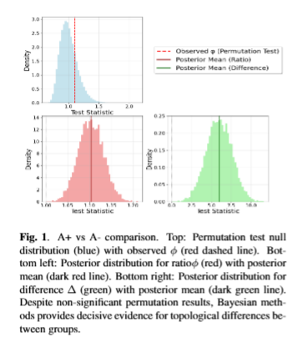

Persistent Homology on Proteomic Data

Data used in the preparation of this article were obtained from the Alzheimer’s Disease Neuroimaging Initiative (ADNI) database (adni.loni.usc.edu). The ADNI was launched in 2003 as a public-private partnership, led by Principal Investigator Michael W. Weiner, MD. The primary goal of ADNI has been to test whether serial magnetic resonance imaging (MRI), positron emission tomography (PET), other biological markers, and clinical and neuropsychological assessment can be combined to measure the progression of mild cognitive impairment (MCI) and early Alzheimer’s disease (AD). For up-to-date information, see www.adni-info.org.
Persistent homology is a method from topological data analysis that helps us understand the shape and structure of complex data without making strong assumptions. It works by identifying stable patterns (like clusters or loops) that persist across different scales, which makes it especially useful for detecting meaningful structure in noisy biological data.
In our analysis, we used persistent homology on proteomic data to uncover the intrinsic organization of Alzheimer’s disease. We found strong evidence for two dominant subtypes, which appear as stable connected components across the filtration.
Importantly, when we looked more closely at one of these subtypes, we identified three additional sub-subtypes, suggesting a more hierarchical structure rather than a simple flat classification. This indicates that Alzheimer’s disease may have layered heterogeneity, with finer-grained variation within major groups.
These subtypes were primarily distinguished by differences in canonical Alzheimer’s disease biomarkers and related molecular profiles. One subtype showed higher total tau and phosphorylated tau levels, together with increased APOE ε4 carrier frequency, consistent with a more tau-associated disease profile. The second subtype exhibited lower tau pathology and a comparatively milder molecular pattern. Within the dominant subtype, the identified sub-subtypes further separated individuals into groups with low, intermediate, and high tau burden.
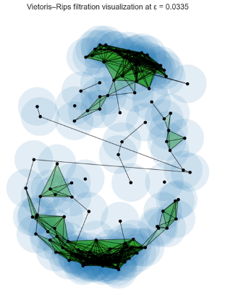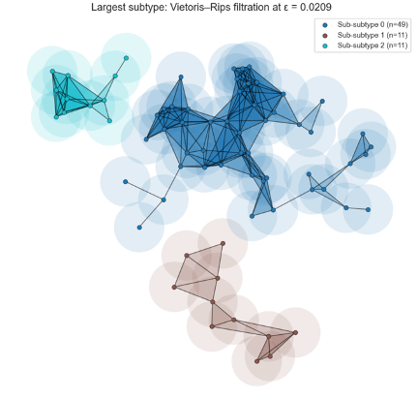
Figure 2 Multi-scale Vietoris–Rips filtration visualizations of proteomic similarity structure across discovery cohort.
Top left: Vietoris–Rips filtration of the full discovery cohort at the PH-selected threshold (ε = 0.0335), illustrating the emergence of two dominant connected components (H_0), consistent with the primary subtype separation. Top right: Filtration restricted to the largest subtype, revealing three sub-subtypes at a finer scale (ε = 0.0209), corresponding to internal H₀ splits within the dominant cluster. In all panels, nodes represent patients, edges indicate pairwise similarity below ε, and filled triangles denote higher-order simplices (2-simplices), highlighting local geometric connectivity. The persistence of these structures across scales supports a hierarchical organization of Alzheimer’s disease heterogeneity.

Markov Progression and Autoregressive Modeling for Disease Evolution
We will now look at modeling Alzheimer’s progression through a Markov framework. In a pure Markov model, the next state depends only on the current state, and not on any previous states. In disease progression, however, this is often not true, as time spent in a state plays a role in progression. We therefore modeled Alzheimer’s progression using a semi-Markov framework, taking into account the current state and time spent in the state.

Next, we aim to predict disease worsening through an autoregressive model. The NACC UDS dataset is heavily imbalanced when it comes to progression, as patients stay in the same state between visits over 90% of the time. We therefore used a class-weighted autoregressive model, modifying the loss function to penalize rare class progression more heavily. The degree 2 autoregressive model conditions on the current state, previous state, and gap between visits. We used a train-test split to select a threshold of .675 that was the disease progression boundary, chosen by maximizing the F1 score on the training set. Next steps include adding more NACC variables with significant predictive ability, such as sex and age, to better model the relationship.
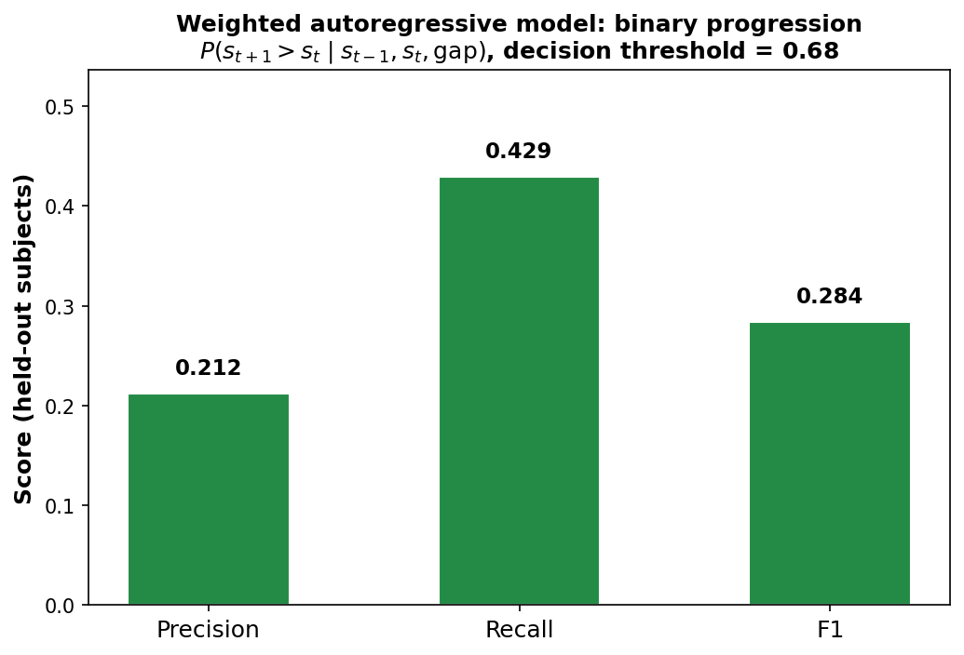

EEG Brain Activity
We extended our multi-modal framework to electroencephalography (EEG), a non-invasive modality that captures brain activity with high temporal resolution. Unlike structural or molecular data, EEG reflects real-time neural dynamics, making it well-suited for identifying functional disruptions associated with neurological disease.
In our analysis, we extract spectral bandpower and functional connectivity features to characterize differences in brain activity across Alzheimer’s disease (AD), Frontotemporal Dementia (FTD), and control groups. These features are then used as input to classification models, allowing us to evaluate the extent to which EEG-derived signals can distinguish between clinical populations.
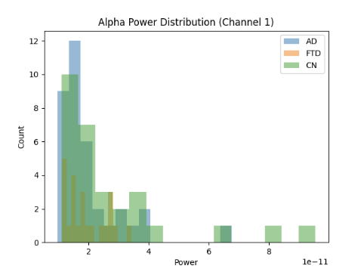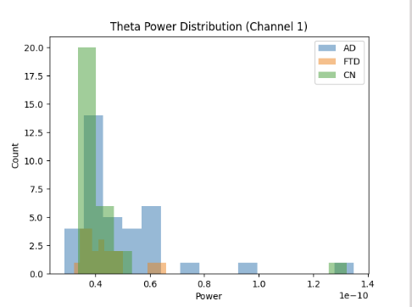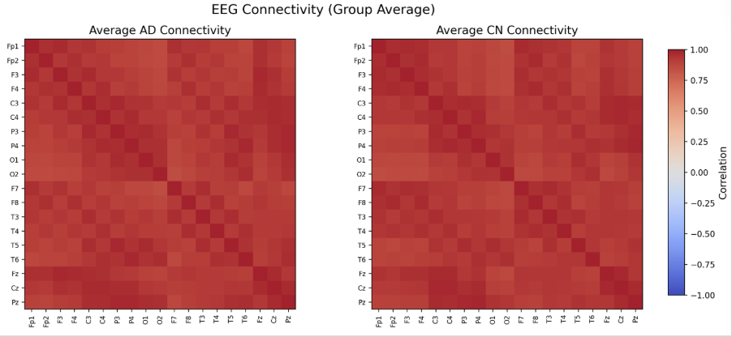

From the Alpha & Theta power distribution, we see some visually distinct features between AD, FTD, and CN diagnoses. From the EEG Average Functional Connectivity analysis, we see that there are strong positive correlations across channels, similar structure across groups, and that the differences are subtle. Next steps would be to extract more informative features such as bandpower ratios (e.g., theta/alpha), time-frequency representations like STFT or wavelets, and advanced connectivity measures like coherence, along with using larger datasets and more refined graph-based approaches, which may help improve classification performance.
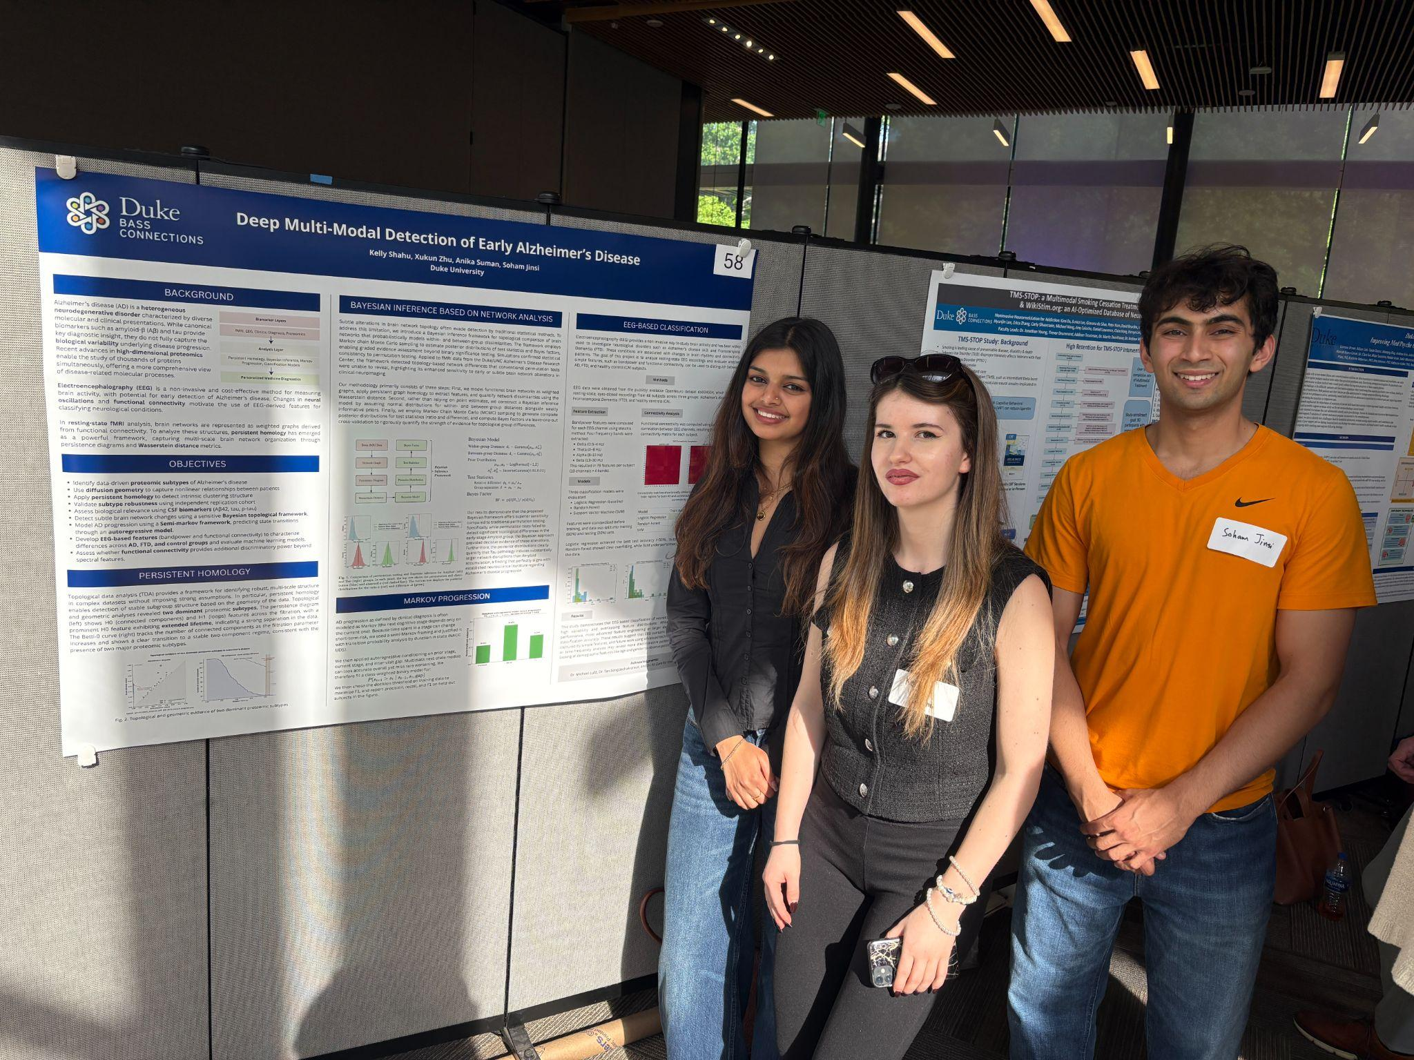
Our Team Members presenting at the Bass Showcase
Left to Right: Anika Suman, Kelly Shahu, Soham Jinsi

Conclusion and Learning
Alzheimer’s is a deeply complex disorder requiring a multi-modal approach to capture early-stage network changes. By combining neuroinformatics with topological data analysis, we learned how molecular pathology translates into functional brain disruptions often missed by traditional methods. Navigating and interpreting real-world data from NACC, including the difficulty in modeling rare events, taught us the value of methodological flexibility in research. Furthermore, EEG functional connectivity and proteomic subtyping allowed us to see how these changes manifest in neural signatures. This collaborative effort spanned neuroscience, statistics, and computer science, teaching us the importance of a diverse team in uncovering insights from research.

References and Acknowledgement:

Research reported in this publication was supported by the Duke/UNC Alzheimer’s Disease Research Center of the National Institute on Aging of the National Institutes of Health under Award Number P30AG072958. The content is solely the responsibility of the authors and does not necessarily represent the official views of the National Institutes of Health.

Alzheimer’s Disease Neuroimaging Initiative (ADNI). ADNI Data Repository. Available at: https://adni.loni.usc.edu
The NACC database is funded by NIA/NIH Grant U24 AG072122. NACC data are contributed by the NIA-funded ADRCs: P30 AG062429 (PI James Brewer, MD, PhD), P30 AG066468 (PI Oscar Lopez, MD), P30 AG062421 (PI Teresa Gomez-Isla, MD), P30 AG066509 (PI Thomas Grabowski, MD), P30 AG066514 (PI Mary Sano, PhD), P30 AG066530 (PI Helena Chui, MD, Arthur Toga, PhD), P30 AG066507 (PI Marilyn Albert, PhD), P30 AG066444 (PI David Holtzman, MD), P30 AG066518 (PIs Lisa Silbert, MD, Kevin Duff, PhD), P30 AG066512 (PI Thomas Wisniewski, MD), P30 AG066462 (PI Scott Small, MD), P30 AG072979 (PI David Wolk, MD), P30 AG072972 (PIs Charles DeCarli, MD, Rachel Whitmer, PhD), P30 AG072976 (PI Andrew Saykin, PsyD), P30 AG072975 (PI Julie Schneider, MD, MS), P30 AG072978 (PI Ann McKee, MD), P30 AG072977 (PI Robert Vassar, PhD), P30 AG066519 (PI Joshua Grill, PhD), P30 AG062677 (PIs Brad Boeve, MD, Ronald Petersen, MD, PhD), P30 AG079280 (PI Jessica Langbaum, PhD), P30 AG062422 (PI Gil Rabinovici, MD), P30 AG066511 (PI Allan Levey, MD, PhD), P30 AG072946 (PI Linda Van Eldik, PhD), P30 AG062715 (PI Sanjay Asthana, MD, FRCP), P30 AG072973 (PI Russell Swerdlow, MD), P30 AG066506 (PIs Glenn Smith, PhD, ABPP, David Lowenstein, PhD, Ranjan Duara, MD), P30 AG066508 (PIs Stephen Strittmatter, MD, PhD, Christopher Van Dyck, MD), P30 AG066515 (PI Victor Henderson, MD, MS), P30 AG072947 (PI Suzanne Craft, PhD), P30 AG072931 (PI Henry Paulson, MD, PhD), P30 AG066546 (PIs Sudha Seshadri, MD, Gladys Maestre, MD, PhD), P30 AG086401 (PI Erik Roberson, MD, PhD), P30 AG086404 (PI Gary Rosenberg, MD), P30 AG086403 (PI Angela Jefferson, PhD), P30 AG072958 (PIs Heather Whitson, MD, Gwenn Garden, MD, PhD), P30 AG072959 (PI Jagan Pillai, MD, PhD), P30 AG092752 (Ihab Hajjar, MD, MS).

Miltiadous, Andreas, et al. A Dataset of EEG Recordings from: Alzheimer’s Disease, Frontotemporal Dementia and Healthy Subjects. Version 1.0.8, OpenNeuro, 2023, https://doi.org/10.18112/openneuro.ds004504.v1.0.8.

