AMR in a Changing Climate-Bass Connections Team Profile

Figure 1-Team members during an online meeting.
The Antimicrobial Resistance and a Changing Climate: A One Health Policy Framework project is an interdisciplinary research collaboration supported by Duke University’s Bass Connections program. The team brings together faculty and students from Duke Kunshan University (DKU) and Duke University alongside international collaborators from the Duke-Ruhuna Collaborative Research Center in Sri Lanka to address the intersection of two critical global challenges: antimicrobial resistance (AMR) and climate change.
The project is co-led by Annemieke van den Dool, Assistant Professor of Environmental Policy at DKU, and Gayani Tillekeratne, Associate Professor of Medicine and Global Health at Duke University and Duke Global Health Institute. The multidisciplinary team includes DKU undergraduates Xiaohang Lyu, a political economy and public policy student; Yijin Niu, a global health and public policy student; Khanh Tuong Tran, from the division of social science; mathematics student Jaemin Kim at Duke University, and infectious disease and global health fellow Lana Abusalem at Duke University Hospital along with SLP Evin, RN, a junior researcher at the Duke-Ruhuna Collaborative Research Centre in Sri Lanka. The team integrates expertise across global health, medicine, environmental policy, and quantitative sciences, reflecting a true collaborative approach to the multifaceted challenge of AMR.
Because of the team’s international nature, the project operates as a globally connected virtual collaboration, with members based in the United States, Sri Lanka, Vietnam, and China. Regular meetings are conducted via Zoom™, enabling real-time interdisciplinary exchange across time zones. This structure facilitates continuous engagement, and cross-cultural exchanges of experiences and research.
Grounded in the One Health framework (which recognizes the interconnectedness of human, animal, plant, and environmental health), the team investigates a central question: What are the available evidence, policy landscape, and opportunities for policy action regarding the connection between climate change and antimicrobial resistance?
To address this question, the team employs two primary methodological approaches:
- Comparative Policy Analysis: Developing a database of National Action Plans (NAPs) to evaluate how countries incorporate (or fail to incorporate) climate considerations into AMR strategies.
- Systematic Literature Review: Identifying and synthesizing global evidence on the relationship between AMR and climate change using the Covidence platform
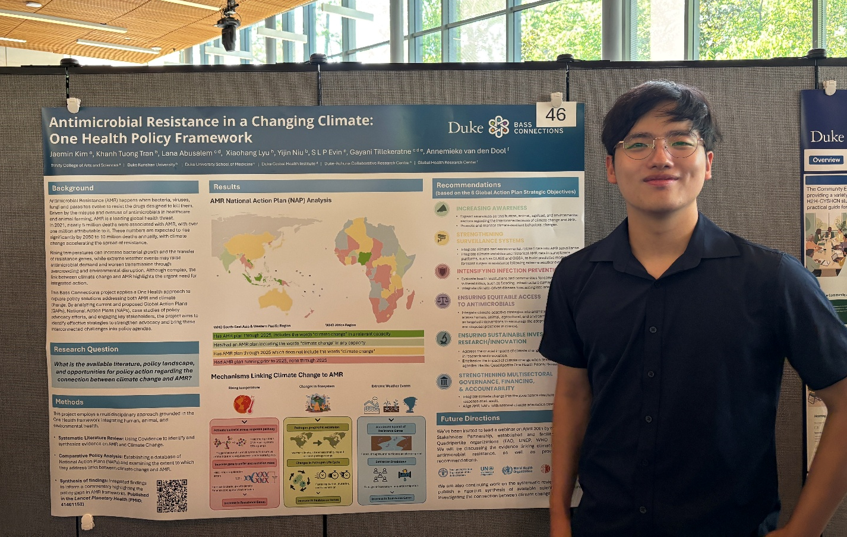
Figure 2-Jaemin Kim presenting the team’s work at the Bass Connections Showcase held at Duke University.
The team has already published a policy commentary in The Lancet Planetary Health (Bridging the policy gap between climate change and antimicrobial resistance, 2025. PMID: 41461152) highlighting the gap between climate change and AMR policy. In addition to this work, the team submitted formal comments to the Global Action Plan (GAP) on Antimicrobial Resistance drafters and is currently advancing a systematic review that rigorously investigates the available published literature. Their work has garnered international attention, prompting an invitation to present at a global webinar hosted by the AMR Multi-Stakeholder Partnership Platform convened by the Quadripartite organizations (FAO, UNEP, WHO, and WOAH), where the team shared evidence and proposed actionable policy recommendations to better integrate climate change into global AMR action frameworks.
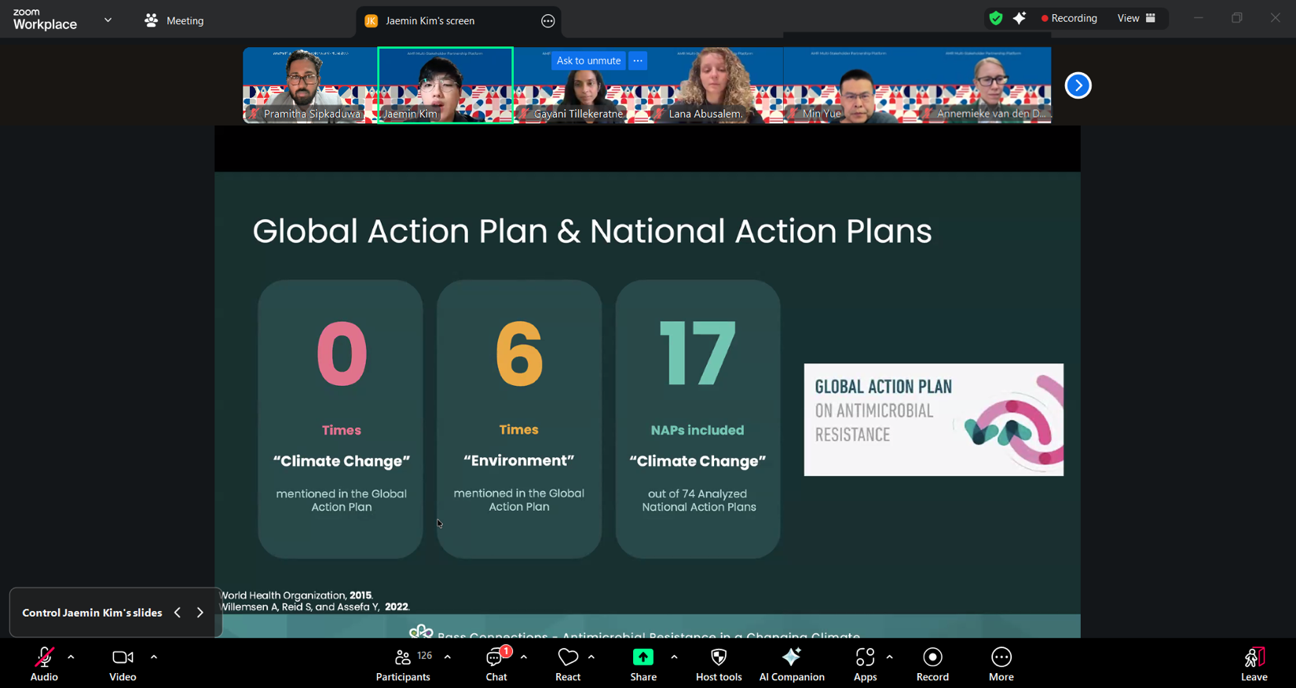
Figure 3-The team shared their findings and expertise at the AMR Multi-Stakeholder Partnership Platform, held on 30 April 2026 and organized by the Quadripartite.

